Math 1 Name ________________________

**3-1 Practice** Date________

The equations below represent the percent of male and female teachers in the Mayfield District starting in the year 1950.

Female: 

Male: 

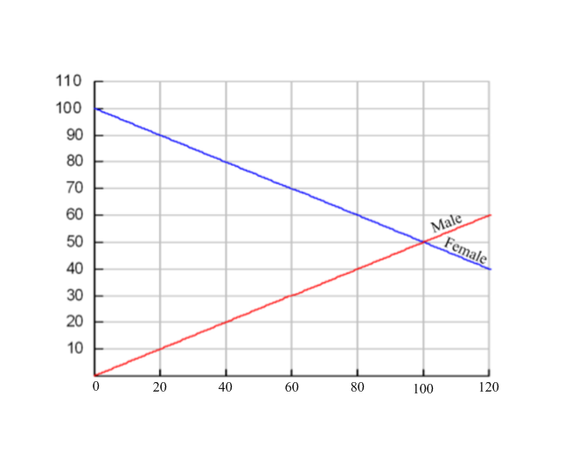

|  |  |  |
| --- | --- | --- |
| *x* |  |  |
| 0 | 100 | 0 |
| 10 | 95 | 5 |
| 20 | 90 | 10 |
| 30 | 85 | 15 |
| 40 | 80 | 20 |
| 50 | 75 | 25 |
| 60 | 70 | 30 |
| 70 | 65 | 35 |
| 80 | 60 | 40 |
| 90 | 55 | 45 |
| 100 | 50 | 50 |
| 110 | 45 | 55 |

Answer the following questions using the table and graph. Then explain how you can find the answer using either the graph or the table. Also, write a sentence explaining what your answer means. I am expecting an answer and two sentences.

1. What percent of the teachers were male in the year 1975?
2. In what year will the percent of teachers that are female be 40%?
3. In what year will the percent of male’s teachers equal the females?
4. What years will the percent of male teachers be greater than females?
5. When will the percent of female teachers be four times larger than the male percent?

What questions could be answered by the following equations and inequalities? I also want you to solve them using the table and graph and explain what the answer means.

1. 
2. 

|  |  |  |
| --- | --- | --- |
| *x* |  |  |
| 0 | 100 | 0 |
| 10 | 95 | 5 |
| 20 | 90 | 10 |
| 30 | 85 | 15 |
| 40 | 80 | 20 |
| 50 | 75 | 25 |
| 60 | 70 | 30 |
| 70 | 65 | 35 |
| 80 | 60 | 40 |
| 90 | 55 | 45 |
| 100 | 50 | 50 |
| 110 | 45 | 55 |

1. 100 – 0.5*x* = 2(0.5*x*)
2. 
3. 

Graph the following:

 

